**Software Now**

**HIT 137**

**Assignment 3 Question 3**

**Group CAS076**

Gilbertofer Tanoto (S379097)

Phat Nguyen (S365522)

Umais Ahamed Anwar Ali (S373981)

Syed Sayed Hasan (S377467)

**Casuarina Campus Sem2 2024**

**Group Assignment Report: GitHub Repository Creation**

**Course:** HIT137 Software Now  
**Assignment:** Assignment 3  
**Group:** CAS076  
**Members:**

* Gilbertofer Tanoto (S379097)
* Phat Nguyen (S365522)
* Umais Ahamed Anwar Ali (S373981)
* Syed Sayed Hasan (S377467)  
  **Campus:** Casuarina Campus, Sem2 2024

**Step 1: Repository Setup**

* **Repository Name:** A new public repository named HIT137_Assignment3_CAS076 was created on GitHub.
* **Visibility:** The repository was set to **public**, ensuring accessibility to all group members and providing a platform for collaboration.

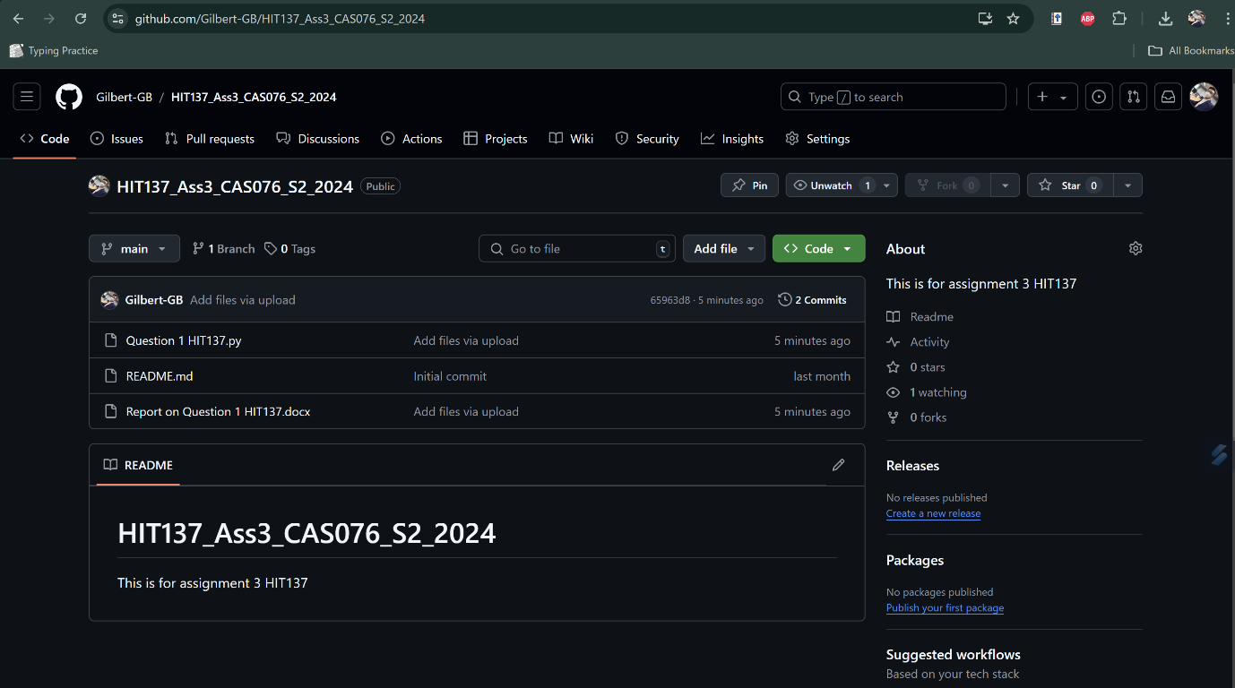

**Step 2: Adding Group Members**

* **Collaborators:** All group members were added to the repository:
  1. Gilbertofer Tanoto
  2. Phat Nguyen
  3. Umais Ahamed Anwar Ali
  4. Syed Sayed Hasan

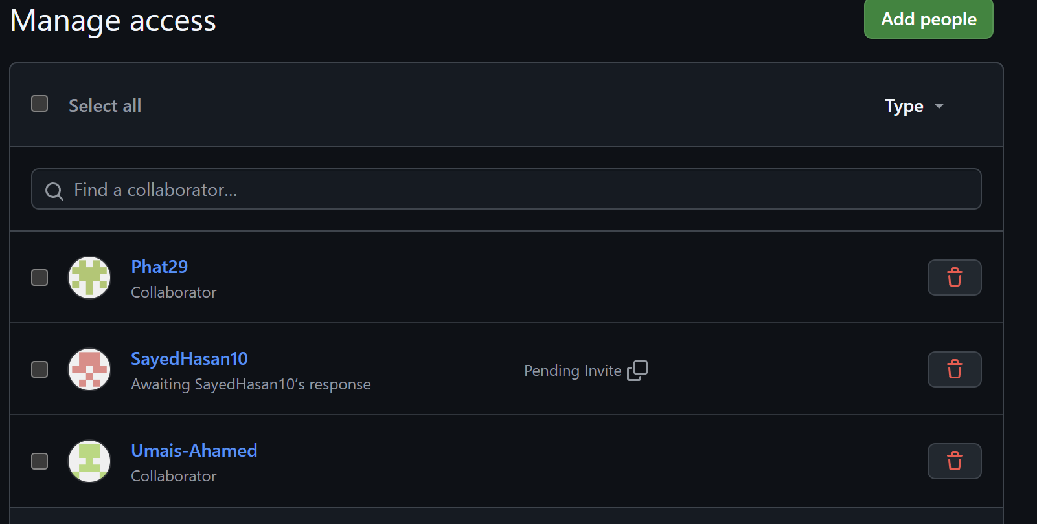

**Step 3: Version Control and Task Management**

* **Reports on Each Question:** Since the assignment consists of three questions, the repository is organized to contain separate reports for each question. Group members will contribute answers and solutions specific to each question:
  + **Question 1:** A dedicated report file for Question 1.

**Task Division and Roles**

* **Phat Nguyen:**  
  Phat constructed the main program structure, focusing on integrating window management and file operations in Tkinter. He also built the user interface, ensuring it was simple and intuitive for users.
* **Gilbertofer Tanoto:**  
  Gilbert ensured the application followed OOP best practices, particularly focusing on **encapsulation**. He helped design the image classification method, protecting it from external access and maintaining code integrity.
* **Umais Ahamed Anwar Ali:**  
  Umais implemented a **decorator** to log classification actions whenever an image was processed, adding transparency by recording which images were classified.
* **Syed Sayed Hasan:**  
  Sayed worked on making the program flexible by implementing **polymorphism**, allowing for future integration of different AI models. He also collaborated with Gilbert on developing the mock classification system.
  + **Question 2:** A report for Question 2.
  + **Question 3:** A report for Question 3.
* **Commit Messages:** Clear commit messages will accompany each contribution to indicate updates or solutions for specific questions, e.g., Completed report for Question 1.
* **Branching Strategy:** Each member will work on their question or section in separate branches to prevent conflicts and ensure smooth collaboration.

**Step 4: Documentation and Final Submission**

* All final versions of the reports for each question will be merged into the main branch before the submission deadline.
* Any code or additional files relevant to the questions will be included in the respective sections of the repository. Gilbert will made the final submission in the Learline representing Group CAS 076

**Conclusion:**  
The public GitHub repository serves as a collaborative space for Group CAS076 to manage and submit the three-question assignment for HIT137. Each question will have its own report, and all contributions will be tracked for transparency.